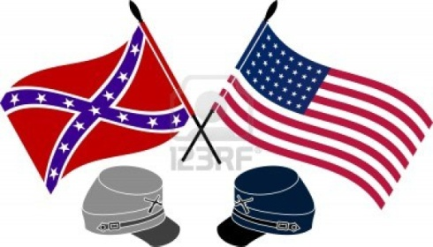

**Name:**

**Civil War Non-Fiction**

**Cite your book below using MLA style (Remember, your format is print):**

Author last name, First name. Title of the Book. Place of publication: Publisher, year of publication. Format.

**This book is about (summarize in 2-3 sentences)...**

**This book describes this time period….in this part of the country… (when and where, be specific)**

**Name three people who are important in this book. Write one fact about each person…**

1.

2.

3.

**The events in this book shaped America’s history by… (2-3 sentences)**

**Three reasons I liked/didn’t like this book are…**

1.

2.

3.

**If I could travel back to this time and place, I would want to…because….(go somewhere, do something, meet someone – be specific: what and why) (2-3 sentences)**

**I chose to read this book because… (1-2 sentences)**