[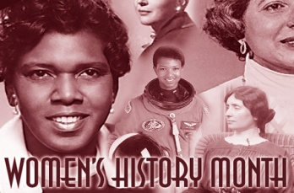](http://images.google.com/url?sa=i&rct=j&q=women%27s+history+month&source=images&cd=&cad=rja&docid=JKoyJMwy0SYKmM&tbnid=v2OX_oFTjrUmeM:&ved=0CAUQjRw&url=http%3A%2F%2Fwww.uakron.edu%2Fim%2Fonline-newsroom%2Fnews_details.dot%3FnewsId%3D938938%26crumbTitle%3DUniversity%2520of%2520Akron%2520Hosts%2520Women%25E2%2580%2599s%2520History%2520Month%2520events&ei=Z1kRUcm8HcHa0QHX4IDQAg&bvm=bv.41867550,d.dmQ&psig=AFQjCNEB8cfZXYsAq30Qc9YNtvJPDFtDeg&ust=1360177887871062)[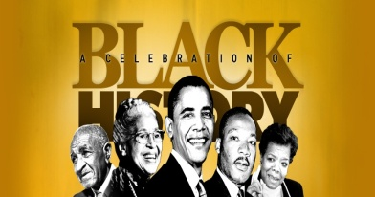](http://images.google.com/url?sa=i&rct=j&q=black+history+month&source=images&cd=&cad=rja&docid=tKOF3AJ0o66RpM&tbnid=JKft_HmwtKEFSM:&ved=0CAUQjRw&url=http%3A%2F%2Fwww.iaohra.org%2Fcelebrate-black-history-month%2F&ei=DFoRUcq7BqW10AH_m4GoDQ&bvm=bv.41867550,d.dmQ&psig=AFQjCNFiTMTKSkPvRXek6LAIjrAfs8uvSw&ust=1360178043629276)

**Name:**

**Black & Women’s History Month Nonfiction Book Report**

**Cite your book below using MLA style (Remember, your format is print):**

Author last name, First name. Title of the Book. Place of publication: Publisher, year of publication. Format.

**This book is about (summarize in one or two sentences)...**

**Describe this person’s early life (family, education, where he/she grew up, etc.)…**

**Name three people who helped your person in his/her life. Write one fact about each person…**

1.

2.

3.

**The biggest problems or obstacles this person(s) had to overcome are…**

**Three reasons I liked/didn’t like this book are…**

1.

2.

3.

**If I could ask this person one question it would be the following because…**

**This person has influenced/contributed to the community, country, or world by…**

**Three interesting facts I learned about this person(s) from this book are…**

1.

2.

3.