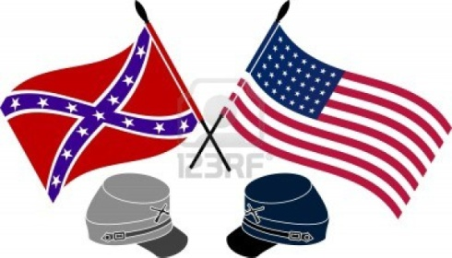

**Name:**

**Civil War Historical Fiction**

**Cite your book below using MLA style (Remember, your format is print):**

Author last name, First name. Title of the Book. Place of publication: Publisher, year of publication. Format.

**This book is about (summarize in 2-3 sentences)...**

**This book takes place in/around….during.… (where and when) note: be as specific as possible**

**Name three main characters. Write one fact about each person and his/her relationships with other characters**

1.

2.

3.

**A main event(s) in this novel is…and this happened because… (2-3 sentences)**

**Three reasons I liked/didn’t like this book are…**

1.

2.

3.

**This novel is considered historical fiction because… (1-2 sentences)**

**The main event(s) that are historical in this novel are important because…(did it change history, did other events happen as a result of this event…?) (1-2 sentences)**

**I chose to read this book because… (1-2 sentences)**